# INTRODUCTION

# In an era of growing concern over the safety, authenticity, and quality of pharmaceutical products, the concept of drug traceability has emerged as a critical solution to address these pressing issues. Drug traceability, also known as pharmaceutical traceability, refers to the ability to track and trace pharmaceutical products throughout their entire lifecycle within the supply chain, from the point of manufacturing to the hands of the end consumer. This systematic approach provides a comprehensive means of verifying the legitimacy, quality, and safety of medications, ultimately safeguarding public health and building trust in the pharmaceutical industry.

# LITERATURE SURVEY

# Global production networks have adopted supply chains (SCs) as a generic organizational model .SC management is considered a critical inter-organizational mechanism for creating a competitive advantage, particularly in the context of supplier and consumer alliances and networks. Organizational interdependence is emphasized in SC management, with firms working together to achieve SC efficiency.Customers’ numerous demands, such as increased flexibility, velocity, information, and product traceability, have fueled the growth of SCs in recent years. This phenomenon can be explained by several factors, including the acceleration of technological innovations, which allow for better system and process performance; globalisation of trade, which allows customers faster access to products; and environmental responsibility, which prompts customers to inquire about the long-term viability of their purchases .Due to globalisation, fluctuating client expectations, expanded product lines, uncertainty about supplier performance, and a slew of other parameters, SC networks have become more complex, increasing commodities and goods’ production and movement across geographically disparate locations .Contemporary SCs are organically diverse, with multi-echelon, geographically dispersed companies that struggle to service clients. Due to numerous regulating tactics, globalization, and distinct cultural and behavioral traits in this complex network, assessing data and managing risk in SC networks is challenging. Ineffective transactions, pilferage, fraud, and poor SC execution lead to a loss of confidence, which is why SC members require improved data interchange and verifiability.

# IDEATION & PROPOSED SOLUTION

# Develop a comprehensive drug traceability solution that leverages blockchain technology to track and trace pharmaceutical products from production to consumption. The primary purpose of this solution is to:

# Enhance Patient Safety:

# Verify the authenticity and quality of medications to prevent patients

# from consuming counterfeit or substandard drugs, thereby safeguarding their health.

# Improve Supply Chain Transparency:

# Create a transparent and immutable ledger that records the entire journey of pharmaceutical products through the supply chain, increasing accountability among stakeholders.

**Expedite Recalls and Safety Responses:**

Enable rapid identification and targeted recall of unsafe products, reducing the impact of safety concerns on public health.

**Strengthen Regulatory Compliance:**

Facilitate compliance with regional and international regulations, fostering trust between the pharmaceutical industry and regulatory bodies.

**Enhance Data Security**

Utilize blockchain's cryptographic security to protect sensitive data, ensuring the privacy and integrity of information shared within the supply chain.

**Foster Consumer Trust:**

Empower consumers with the ability to verify the authenticity of their medications, bolstering their confidence in the pharmaceutical industry.

**Promote Industry Accountability:**

Encourage pharmaceutical companies, distributors, and other stakeholders to take responsibility for the products they handle, thereby reducing the presence of counterfeit drugs.

**Adapt to Emerging Technologies:**

Stay ahead of the curve by incorporating emerging technologies such as blockchain, IoT, and AI into the drug traceability solution, ensuring long-term relevance and effectiveness.

**Facilitate International Collaboration:**

Promote cooperation and data sharing among global stakeholders in the pharmaceutical supply chain to combat the cross-border issue of counterfeit drugs.

**Address Ethical Concerns:** -

Consider the ethical implications of pharmaceutical traceability, addressing issues like equitable access to medicines and affordability.

**Purpose:** The purpose of this drug traceability solution is to revolutionize the pharmaceutical supply chain by providing a technologically advanced, secure, and transparent method for tracking and tracing pharmaceutical products. It will create a win-win scenario, benefiting patients and consumers by ensuring the safety and authenticity of their medications, while also empowering the pharmaceutical industry to operate more responsibly and ethically. By utilizing blockchain and other advanced technologies, this solution aims to serve as a cornerstone for a safer and more trustworthy pharmaceutical ecosystem, ultimately contributing to the betterment of public health on a global scale.

Top of Form

REQUIREMENT ANALYSIS

In this section, we present a comparative analysis of the proposed solution for traceable supply chain for pharmaceutical drugs with relevant existing solutions. A summary of this analysis is presented in Table 1.

The proposed solution is decentralized which is an important feature as it prevents any single entity from manipulating or modifying the data. Another important feature of our solution is resilience, since the solution is decentralized, it eliminates single point of failure. Blockchain offers excellent solution for data integrity and security due to its features such as data immutability, therefore once the information is added to the edger it cannot be removed or modified. The security of data is maintained because it’s stored in a decentralized way which makes no single entity capable of simultaneous manipulation of data. Transparency of transactions is an important aspect for any supply chain. In our proposed solution, all participants can access and view the verified all transactions in a trusted environment. Finally, all the solutions in Table 1 share one common feature which is the track and trace feature, however other features such as decentralized storage, integrity and transparency are fundamental to achieving a trustworthy track and trace system.

Table 2 compares our proposed solution with other blockchain-based solutions. Our solution uses Ethereum blockchain where as the solution in [34] uses Bitcoin blockchain and the solution in [32] uses Hyperledger-Fabric. Moreover, both our solution and [34] operate in public permissioned mode whereas [32] operates in private permissioned mode which is an inherent feature in Hyperledgerfabric. The payment method in our solution is Ether which is the currency of Ethereum. The solution in [34] uses BTC currency and [32] does not have a currency. Furthermore, in all solutions data is stored on-chain but our solution has an additional feature which allows storing data off-chain as well. Finally, Both our solution and [32] have programmable modules which are the smart contract and docker container respectively. However, the solution in [34] does not provide a programmable module.

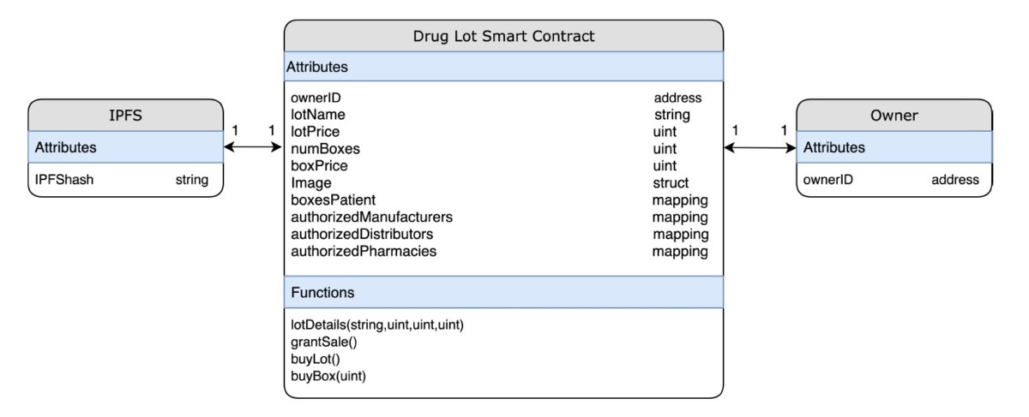

# PROJECT DESIGN

# the different steps adopted to verify the authenticity of the drug Lot are illustrated. Every drug Lot is manufactured with a smart contract that is specifically designed for it and is responsible for triggering events and logging them on the ledger. A unique Ethereum address is generated for every drug Lot. However, copying Ethereum address of each drug is cumbersome, time consuming, and error prone process. Therefore, a QR code is used which can be easily scanned using smartphones. A QR code is a two-dimensional barcode that is readable by smartphones, and it can allow encoding over 4000 characters in a two dimensional barcode. Mapping an Ethereum address to a QR code can be done by using an Ethereum QR code generator in which the Ethereum address is passed and a unique QR code is generated which will exclusively map to that Ethereum address every time it gets scanned. Once the QR code gets attached to the drug Lot, it can be dispensed to patients.

Figure 7 illustrates the steps to verify the authenticity of a drug. The first step is scanning the QR code that is attached to the drug by using a DApp which interacts with the Ethereum node (local or remote node) through web3j. To map the QR code to its corresponding Ethereum address, the DApp has to interact with the Ethereum node (Infura for example) through JSON-RPC. The Ethereum node has a replica of the ledger, and it is extremely important for the users because it makes the process smooth and easy by saving them the effort of having to set up their own Ethereum node which takes a lot of time. The gateway (Ethereum node) will map the Ethereum address of the drug Lot to the smart contract which will point to the events of the different functions of the smart contract that are stored in the ledger [45].

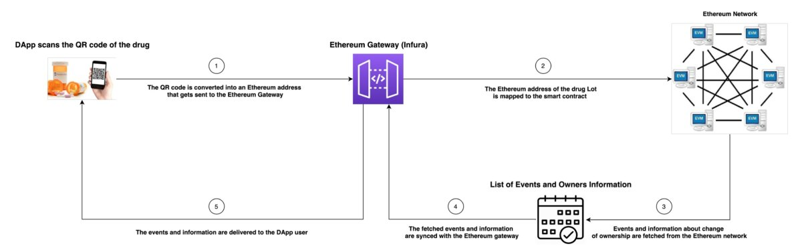

# PROJECT PLANNING & SCHEDULING

# The proposed work in this paper demonstrates how blockchain technology can be applied for drug traceability in a pharmaceutical supply chain. Although the functions  in the smart contract were defined in a way that fits the pharmaceutical supply chain specifically, it can be easily extended to other types of supply chains [47].The main difference between the pharmaceutical supply chain and any other supply chain is the products/items that are being shipped, distributed, and sold and the way they are handled throughout the process. For example, some pharmaceutical drugs require very specific conditions like temperature and humidity while they are being transferred from a point to another whereas a spare part supply chain for example would have very different conditions. Since live tracking is out of the scope of this paper, tracing the origin of a product/item regardless of its type will be very similar because it only requires the scanning of a unique identification code which is attached to the product/item and the DApp will handle the rest. The only difference might occur in the way unique identifications are generated for the products/items which does not hinder the process.Figure 2 can be used as a reference to discuss the generalized application of the proposed solution in a different supply chain. Based on the specific supply chain application, for example, food, spare parts or other application the stakeholders of the supply chain and their role needs modification. Moreover, the use of a decentralized storage system might not be needed in cases where there is no necessity to store and access large data files from off-chain. Finally, the onchain resources can be modified according to the needs of the proposed application, for example, a reputation system, payment and funds transfer setup might not be needed. In such cases the on chain storage will be more than adequate to retain the transaction logs amid stakeholders.The entity relationship diagram can be also modified, for example, if a supply chain has an application that requires the use of more than one parent smart contract then it will have to be added and define its relationship with the other entities. Another possibility is the creation of more than one product at a time which requires an extension to the functions to accommodate the additional products, and this can be achieved by modifying the existing smart contract.Finally, the defined algorithms follow simple and easy to grasp steps, and similar algorithms are followed in many other supply chains [48]. This fact can be used to adjust the customize the algorithms used in this paper to fit the needs of specific supply chain application.

# *B. COST ANALYSIS*

# This subsection presents cost analysis of the Ethereum smart contract code and the function calls. When a transaction is executed on the Ethereum blockchain, it costs gas to send it to the Ethereum blockchain. Remix IDE is a very useful and easy to use tool to estimate the gas costs for the execution and transaction which are the main types of gas costs. The execution cost is the cost of executing different functions in the smart contract whereas the transaction cost deals with several factors such as the deployment of the contract, and any data that gets sent to the blockchain network. Table 4 shows the gas costs of the different functions used in the smart contract, and it also shows the costs converted into fiat currency (USD). An average gas price of 2.8 GWEI was used according to the ETH gas station [49] pricing accessed on Apr 10, 2020. It should be noted that gas prices vary over time and the ones used here will most likely change. However, they have been used in this context to show that the cost of executing these functions is relatively low. Furthermore, a paid oracle service (Chainlink for example) can be used to get the latest price of Ethereum which is then used to convert the transaction and executions costs into USD.

**CODING & SOLUTIONING (Explain the features added in the project along with code)**

# PERFORMANCE TESTING

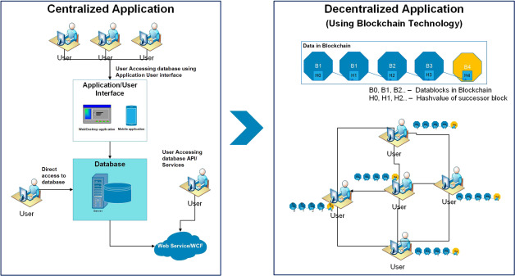

# RESULTS

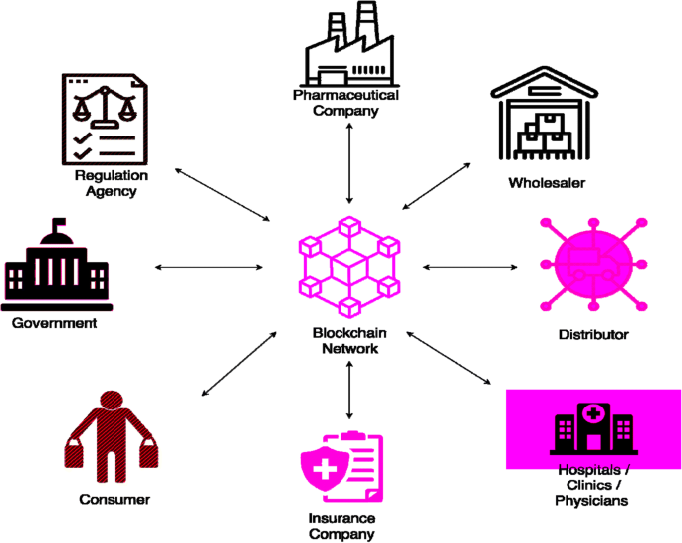

# ADVANTAGES & DISADVANTAGES

Advantage:

1. **Enhanced Security:** Blockchain technology provides a high level of security through cryptographic techniques. It ensures that once data is recorded, it is nearly impossible to alter, making it a highly secure system for tracking pharmaceutical products.
2. **Immutability:** Data recorded on a blockchain is immutable, meaning it cannot be changed or deleted. This feature ensures the integrity of the information related to drug traceability, reducing the risk of fraudulent activities.
3. **Transparency:** Blockchain offers transparency throughout the supply chain. All authorized stakeholders can view the same real-time data, leading to greater accountability and trust among participants.
4. **Reduced Counterfeiting:** Blockchain-based traceability systems make it exceptionally difficult to introduce counterfeit drugs into the supply chain. Consumers and regulators can verify the authenticity of products easily.

Disadvantage:

1. **Initial Implementation Costs:** Setting up a blockchain-based drug traceability system can be costly. It involves technology development, infrastructure investment, and training for stakeholders.
2. **Scalability:** As more products and transactions are added to the blockchain, its size and complexity can grow, potentially impacting the speed of data processing.
3. **Interoperability:** Ensuring compatibility between different blockchain networks and legacy systems can be challenging. Achieving seamless integration with existing supply chain processes may require additional effort.
4. **Data Privacy:** While blockchain offers a high degree of security, concerns about data privacy persist. Sensitive information on the blockchain needs to be protected, and compliance with data privacy regulations is vital.
5. **Regulatory Compliance:** Depending on the jurisdiction, regulatory compliance can be complex. Blockchain traceability systems must align with regional and international regulations, which may vary.
6. **User Education:** Stakeholders within the pharmaceutical supply chain need to be educated on how to use the blockchain system effectively, which requires time and resources.
7. **Centralization vs. Decentralization:** Striking the right balance between centralized and decentralized control can be a challenge. Centralized control may raise concerns about data monopolies, while excessive decentralization can lead to governance issues.

# CONCLUSION

we have investigated the challenge of drug traceability within pharmaceutical supply chains highlighting its significance especially to protect against counterfeit drugs. We have developed and evaluated a blockchain-based solution for the pharmaceutical supply chain to track and trace drugs in a decentralized manner. Specifically, our proposed solution leverages cryptographic fundamentals underlying blockchain technology to achieve tamper-proof logs of events within the supply chain and utilizes smart contracts within Ethereum blockchain to achieve automated recording of events that are accessible to all participating stakeholders.

We have demonstrated that our proposed solution is cost efficient in terms of the amount of gas spent in executing the different functions that are triggered within the smart contract. Moreover, the conducted security analysis has shown that our proposed solution achieves protection against malicious attempts targeting is integrity, availability and nonrepudiation of transaction data which is critical in a complex multi-party settings such as the pharmaceutical supply chain.

We continue our efforts to enhance the efficiency of pharmaceutical supply chains and envision to focus on extending the proposed system to achieve end to end transparency and verifiability of drugs use as future work.

**APPENDIX**

<https://github.com/B08E533DD75B5B1818E433391AAC3022/drug-traceability>